Call for Applications
U.S. – Russia Cybersecurity Simulation with Ambassador Bonnie Jenkins

Application Deadline: Midnight, September 25, 2020

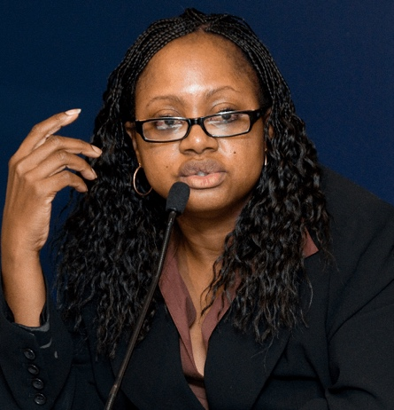
The University of Arizona Department of Russian and Slavic Studies invites applications from current UA undergraduates to take part in a nation-wide Cybersecurity Simulation for undergraduate students held on Nov. 14, 2020. Selected applicants will work with Ambassador Bonnie Jenkins to develop a broad understanding of the different dimensions of peace, security, and foreign policy necessary to resolve international conflict. Ambassador Jenkins will give you and your team the knowledge, skills, and training to champion peace and security.

Participants will meet weekly for training sessions with Ambassador Jenkins, receive a research stipend of $500-$700, gain valuable hands-on experience, and develop their skills in international relations.
Ambassador Bonnie Jenkins, Founder of Women of Color Advancing Peace, Security, and Conflict Transformation

The Cybersecurity Simulation is coordinated by Howard University and made possible thanks to a generous grant from the US Russia Foundation.

We will consider applications from all UA undergraduates, and we strongly encourage students of color to apply.

PROGRAM DETAILS  - Each student will receive a research stipend of $500-$700  - Students must be current undergraduates at UA and be able to meet on Fridays 1:30-2:30PM (local Tucson time) via Zoom  - Students will participate in the virtual cyber event simulation on Nov. 14th, 2020  - NO previous knowledge of Russian is required to take part in the program  - At this time, applicants are eligible for one program, either the Think Tank or Cybersecurity Simulation. However, students may apply to participate in both programs. | HOW TO APPLY  Fill out the following application available here: https://forms.gle/vjodPCCouBRqk9Tu8  - Why is diversity important to you? (100 words or less)  - Why are diverse voices needed in modern-day global peace, security, and conflict challenges? (in 100 words or less)  - Provide current undergraduate transcript (unofficial transcript is acceptable).

For more information, contact Dr. Colleen Lucey at: luceyc@email.arizona.edu

